## **Exercise 1: Control Structures**

## **Scenario 1: Applying a Discount on Loan Interest Rates for Customers Above 60 Years**

### **Aim:-**

### Reduce the loan interest rate by **1%** for all customers whose **age is above 60 years**.

### **Tables Involved**

* **Customers**: CustomerID, Name, DOB
* **Loans**: LoanID, CustomerID, InterestRate

### **Approach**

* Use a **Cursor FOR loop** to fetch customers over 60 along with their loan details.
* For each eligible loan, reduce the **InterestRate** by **1%**.
* **Commit** the changes and display a confirmation message.

### **Age Calculation**

MONTHS_BETWEEN(SYSDATE, DOB) / 12

This calculates the age in years.

### **PL/SQL Block**

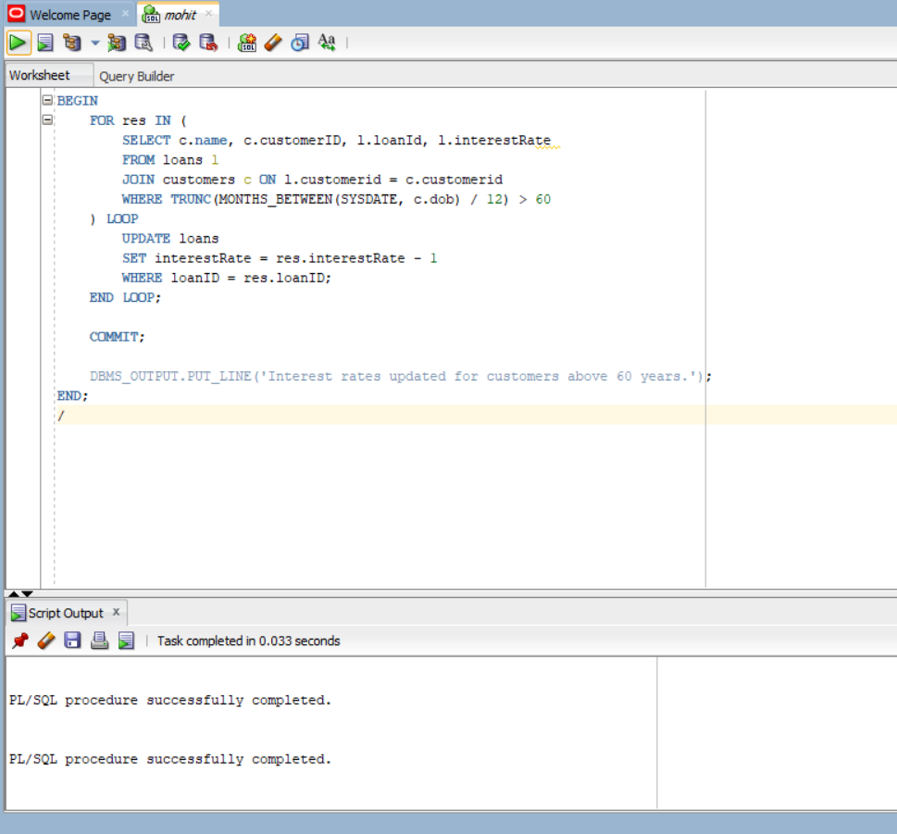

### **Result**

Interest rates for loans of customers above 60 years will be reduced by 1%.

To verify:

SELECT * FROM loans;

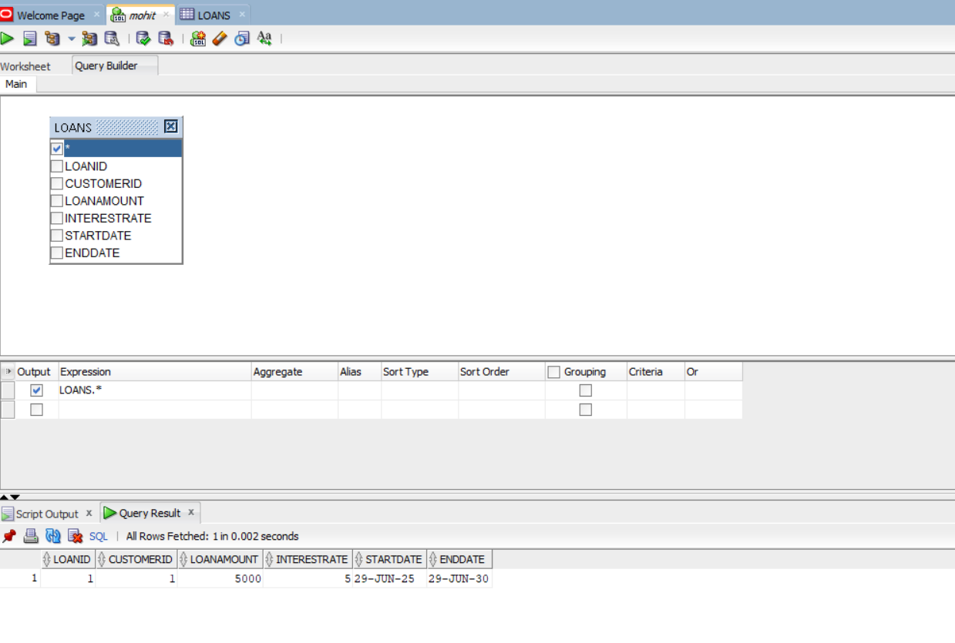

Since there is no Custmer having age greater then 60 so there will be no change.